# ICT171

## Assignment 2: Cloud Project & Video Explainer

### Documentation

Name: Meetkuamr G Patel

Student ID: 34881807

Site Name: freshgrocery.site

Starting: I am going to host my website on Amazon AWS EC2. And here’s how I did all things.

1. Project Overview:

My Project Is about the Fresh Grocery Store.  
At Fresh Grocery, we are committed to delivering the freshest and highest quality produce, dairy, and pantry essentials to ur local community. Our store is a one stop destination for all your grocery needs, where freshness meets affordability and customer satisfaction is our top priority.

* 1. Key Features:
* Home page introducing the grocery store.
* Categories for Fruits, dairy, vegetables and bakery products.
* Integration with SSL and DNS to ensure secure access.
* Hosting through Amazon EC2 and demonstrating Infrastructure as a Service(IaaS).
* Contact Section With business hours and store locations.
  1. Tools I Used For Website:
* Server Host – AWS EC2
* Operating System – Ubuntu
* Website Framework – WordPress
* Domain – Hostinger.com
* Video Hosting – Eco360
* Web Server – Apache2

1. Cloud Server Setup:

First, we need to create an account on Amazon AWS. After that We select the Amazon EC2 for Server Host.

The Next step is we need to Launch Instance. And we need to add Name of the server of name of site. I select the Ubuntu as a operating system and select the free tier.

The next step is we need to create a key pair or create a security group and allow for all traffic data and Allow HTTPS traffic from the internet.

We are ready for Launch Instance. After we launch Instance we can see the Instance at the Instances.

After that we need to go on Elastics Ips, and we need to allocate Elastic IP address, like we can at the top of the right corner.

After that we need to click on the allocate Elastic Ip address and we can see at bottom there is option of the allocate.

After that we can see there is option for Associate this Elastic Ip Address we need to click on that option.

As you can see after the associate the elastic Ip address we need to select our instance and our private Ip address and click on the Associate. After that we can see IP address is appears on the Elastic Ip address list.

After that we need connect that instance with amazon Ec2 and there is option for connect at top of the page

After Connect, the page looks like this.

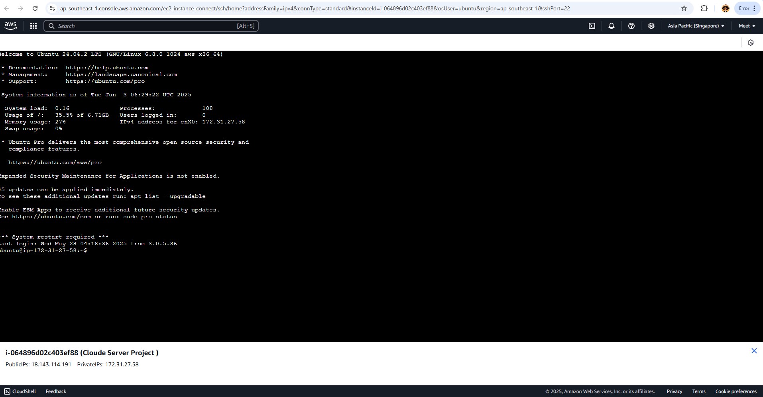

After The we use some code to Install Apache2 server on website.

Here Some code that I use in this Project:

1: sudo apt update

2: sudo apt install apache2

3: sudo nano /var/www/html/index.html

There is photo of First code use:

There is photo of Second Code use:

Use of third code, when we run this code there is index page open and we can add our project details in their and save it. And it’s looks like:

After that when search our IP address you can see the page like this

After That I buy my domain name from Hostinger Site, and my Domain name is

**[freshgrocery.site](https://freshgrocery.site/" \t "_blank)**

After that we need to connect domain name with our IP address, and that thing take some time to connect with Ip address about 10 to 15 minutes. After that when you search your domain name then you got your page like this

Now we are going to install WordPress on our website to add our data and edit the page.

To install WordPress I run some code for that:

1: sudo apt install mysql-server

After that I run this code to enter some detail for the wordpress

* sudo mysql

and it’s looks like:

After that we need to add some details in the mysql for the wordpress:

* create database wordprees;
* create user ‘wpuser’@localhost identified by ‘Testpass123’
* grant all privileges on wordpress.\* to ‘wpuser’@localhost;
* exit;

and after that it’s looks like:

After we need to install wordpress on our site. For that we need to run some code and here the list of code:

* cd /tmp
* wget <https://wordpress.org/latest.tar.gz>
* tar -xvf latest.tar.gz
* sudo mkdir -p /var/www/html/wordpress

After That we need to Install certbot for secure our website with HTTPS.

Here some code that I use for it.

1. Sudo apt install certbot python3-certbot-apache
2. Sudo certbot –apache

When I run the first code it’s look like:

And when I run the second code It’s ask for our email and Ask for Domain name to secure our site, and It’s looks like:

After done all the things and update our page from this code “sudo apt update” after that when you run you website again you can see our website is secure now, and receive our certificate also.

After Installing the wordpress in our website, they asking language and username and server name and all other things. I add Some photos of that. Before that we need to type our site look like this: “frshgroery.site/wordpress” to access the wordpress. But we need to run a code for that to transfer the eordpress file to directory file so when we search our domain name after we got the wordpress.

We need to Run this code to transfer wordpress:

* Sudo mv wordpress/ /var/www/html/

After that if we want to see or check the file come to directory file we need to run this code: cd /var/www/html/ and after that you just need to type “ls” and click the enter you can see your wordpress file is in the directory file.

After we successfully login into the word press we need to add some pages related to our server project.

I Use this command for creating the Website:

* For Install Apache Server on Our Instance:

1. sudo apt update
2. sudo apt install apache 2

* Add Information of our website

1. sudo nano /var/www/html/index.html

* Install mysql server and php file for wordpress

1. sudo apt install php libapache2-mod-php php-mysql
2. sudo apt install mysql-server
3. sudo mysql

after the last code(sudo mysql) we need to create a user and database for wordpress page so we login the page and add our project information or page

1. CREATE DATABASE wp;
2. CREATE USER ‘wpmeet’@localhost IDENTIFIED BY ‘Testmp123’;
3. GRANT ALL PRIVILEGES ON wp.\* TO ‘wpmeet’@localhost;
4. Exit

After that we need to download wordpress

1. Cd /tmp
2. wget <https://wordpress.org/latest.tar.gz>

after downloading the file we need to unzip the file

1. tar -xvf latest.tar.gz
2. sudo mkdir -p /var/www/html/wordpress

after that we need to create a new wordpress config file and add our domain name in that

1. sudo nano /ect/apache2/sites-availabe/wordpress.conf

after we run this code we need to add this information in tht file

“<VirtualHost \*:80>

ServerAdmin admin@freshgrocery.site

ServerName freshgrocery.site

ServerAlias www.freshgrocery.site

DocumentRoot /var/www/html/wordpress

<Directory /var/www/html/wordpress/>

AllowOverride All

</Directory>

ErrorLog ${APACHE\_LOG\_DIR}/error.log

CustomLog ${APACHE\_LOG\_DIR}/access.log combined

</VirtualHost>”

After that we need to move wordpress to the directory file where we store our index.html file

1. sudo mv wordpress/ /var/www/html/

After that we need to restart our site

1. sudo systemctl restart apache2

After we need to secure our website

1. sudo apt install certbot python3-certbot-apache
2. sudo certbot -–apache

Github link: <https://github.com/Meet0611-p/Meet0611-p/edit/main/README.md>

Video Link: <https://echo360.net.au/media/f9d2062d-4682-430b-b7c4-ea39e257ea4e/public>